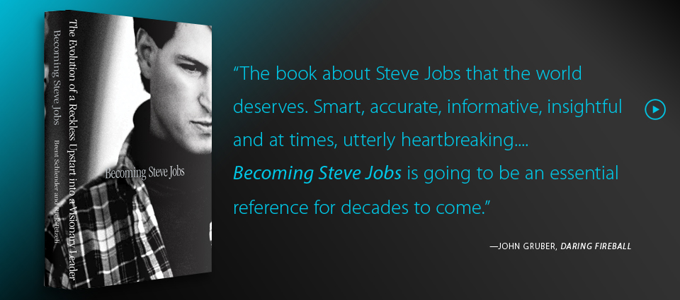

Becoming Steve Jobs
-----Herman
2015.7.24

